KIBAKWE SECONDARY SCHOOL
FORM FIVE – HOLIDAY PACKAGE - SET 04
Code: 133 BIOLOGY

Instructions: Answer all questions

- Describe the mode of action of neurotransmitter at a synapse, including how it is stored and destroyed.
- Distinguish between the following
  - Nervous and hormonal coordination. Give four points.
  - Positive and negative feedback of body temperature regulation process. Give two points.
- (a) Distinguish between structural and function proteins.
  - Draw a large diagram of a typical plant cell as seen under the electron microscope. Indicate using letters below, the cellular structures concerned with:
    - Cellular respiration
    - Protein synthesis
    - Photosynthesis
    - Transport and modification of cellular proteins and lipids
    - Transport and provision of surface area for lipids and steroid synthesis
    - Transport of cellular proteins
    - Control exchange of materials between cells
    - Control cell division
  - What are the possible roles of the cell wall?
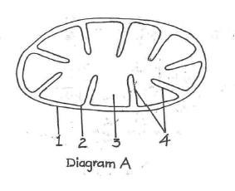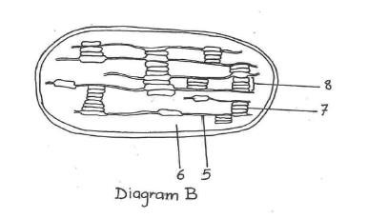
4.

Diagrams A and B represent two cell organelles as seen under the electron microscope

(
i
)

Identify the two cell organelles

  - Name the structures numbered 1-8
  - Without using diagrams, outline the processes taking place in the structures labeled 3 and 8
  - Explain briefly how organelles 1 and 2 are adapted to the functions they perform 5. (a) Describe three (3) ways of obtaining gaseous oxygen in terrestrial flowering plants.
(b) Briefly explain why the oxidation of fats liberates more than double the energy of the same quantity of carbohydrate.

